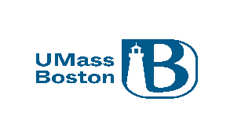

Request for Responses

RFR # MassBays-24-01 (Stage 1 of 2)

Dated: February 1, 2024

Massachusetts Bays National Estuary Partnership

FY24 Healthy Estuaries Grants

1. Grant Opportunity Summary

A. Proposals Sought For: Massachusetts Bays National Estuary Partnership (MassBays), Center within the School for Environment at the University of Massachusetts Boston is soliciting proposals under the FY24 MassBays Healthy Estuaries Grant Program for projects that will advance the implementation of MassBays’ Comprehensive Conservation and Management Plan (CCMP). Through the Healthy Estuaries Grant Program, MassBays will provide funding and technical support to those working in near-shore waters and coastal communities from Salisbury to Provincetown. Eligible projects will:

Characterize estuarine, rocky intertidal, and beach habitats and biological communities.

Document the impacts of human and natural stressors on those systems.

Evaluate effectiveness of habitat restoration efforts already implemented.

Design and scope larger habitat and/or water quality restoration projects for subsequent state or federal funding, especially in underserved communities.

B. Overview and Goals: MassBays is a United States Environmental Protection Agency (EPA) National Estuary Partnership dedicated to protecting, restoring, and enhancing the estuarine ecosystems of Massachusetts and Cape Cod Bays. Working toward our vision of sustainable estuarine ecosystems that support the life and communities dependent upon them, MassBays grant funds are dedicated to support local progress on protecting, restoring, and enhancing estuarine habitats (e.g., seagrass beds, salt marshes, diadromous fish habitat, beaches, and rocky shores) and to inform management efforts to reduce stressors (e.g., climate change, wastewater, stormwater, habitat fragmentation) impacting these habitats.

With the FY24 Request for Response (RFR), we are soliciting projects focused on filling in knowledge gaps revealed by MassBays’ ongoing efforts to characterize the great variability across the planning area (see Section 2.B). We seek information to support MassBays-wide planning as described in our Comprehensive Conservation and Management Plan, as well as local, embayment-specific priorities identified by communities. Projects must include a robust project evaluation process with measurable outcomes that track progress toward short- and long-term project goals.

A requirement of this RFR is the submission of a pre-proposal. The pre-proposal is the first step in which respondents will provide a brief description of the purpose and goals of the study, a summary approach, and total proposed budget. Upon selection by a Review Committee, proponents of successful pre-proposals will be invited to submit a full proposal. Guidelines for submission of the pre-proposal and full proposal are in Section 3.

C. Eligible Projects: Eligible projects include research, monitoring and data analysis, and planning initiatives that advance MassBays’ priorities which focus on protecting, restoring, and enhancing coastal habitats, including shellfish and seagrass beds, salt marshes, diadromous fish habitat, beaches, and rocky shores and the communities that these habitats support. Topics of specific interest include identifying and documenting impacts of specific aspects of climate change on coastal ecosystems and water quality in the 65 assessment areas of the MassBays region.

We are especially interested in proposals for applied research, proof-of-concept activities for restoration methods, efforts to address data gaps, and activities undertaken to support future larger investments (e.g., DEP S.319 grants and DFW In Lieu Fee projects).

Proponents must demonstrate that projects will inform and advance near-term estuarine and coastal management initiatives consistent with the goals of the CCMP. For more details see Section 2B.

D. Eligible Applicants: This solicitation is open to Massachusetts municipalities, Massachusetts 501(c)(3) organizations, regional planning agencies, and nonprofit research institutions, and institutions of higher learning in Massachusetts. See further details in Section 2A.

E. Application Deadlines:
Deadline for Pre-proposal (Stage 1): 2/20/2024, at 12:00 pm
Deadline for Full Proposal (Stage 2): 3/25/2024, at 4:00 pm
(See further details on deadlines and grant program calendar in Section 4).

F. Funding Availability: We anticipate up to $80,000 in federal funds will be available through this solicitation. MassBays reserves the right to change the amount of available grant funding. Final funding amounts are subject to appropriation and approval. A single applicant may request funding amounts between $8,000 and $25,000 per project. Respondents are strongly encouraged to identify and incorporate efficiencies and cost-saving measures to reduce costs as much as possible. (See Funding Availability in Section 2C).

G. Match Requirement: A non-federal match (cash or in-kind) that will equal or exceed 25% of the total project cost is required. Funds from other federal sources or grants, and funds committed to match other federal grants, are not eligible to be used as matching funds.

H. Anticipated Duration of Contract(s): Contracts are anticipated to last approximately 18 months, with an anticipated start date in July 2024 and a completion date of December 31, 2025 (See further detail on Anticipated Duration of Contract[s] in Section 2E).

I. Regulations, Statutes, or Authorization Governing this Grant Program: The award of federal sub-grants is subject to the regulations in 815 CMR 2.00. This grant program is also governed by cooperative agreements between the University of Massachusetts Boston and the U.S. EPA in support of the Massachusetts Bays National Estuary Partnership.

J. Contact Information: Prassede Vella
Massachusetts Bays National Estuary Partnership
100 Morrissey Blvd.
Boston, MA 02125
Email: Prassede.Vella@umb.edu

2. Performance and Contract Specifications

A. Eligible Applicants: This solicitation is open to Massachusetts municipalities, 501(c)(3) non-profit organizations, non-profit research institutions, and institutions of higher learning. Where multiple entities propose a collaborative project, a single grantee will be the recipient of funds, and partners receiving funds through the grantee will be considered subawardees. Subcontractors may include for-profit organizations and state agencies. Only one grant proposal per entity will be awarded, although more than one proposal from a given entity may be submitted for funding.

B. Eligible Projects/Scopes of Work: MassBays seeks proposals for projects that include research and planning initiatives that advance MassBays’ priorities which focus on protecting, restoring, and enhancing coastal habitats, including shellfish and seagrass beds, salt marshes, diadromous fish habitat, beaches, and rocky shores and the communities that these habitats support. Proponents must demonstrate that projects will inform and advance near-term estuarine and coastal management initiatives consistent with the goals of the CCMP and in MassBays’ study area (Attachment A).

Applicants are encouraged to use available resources listed below. Respondents are encouraged to refer to these materials and submit proposals which build on these products, which include:
- Ecosystem Delineation and Assessment (EDA). The EDA characterizes 65 assessment areas using data for the following indicators of estuarine conditions: salt marsh, tidal flats, eelgrass, shellfish habitat, shorebird habitat and nesting sites, anadromous fish passage, land use/land cover, stormwater discharge, impervious area, population density, wastewater discharge, 303(d) impairments (bacteria, nutrients), designated shellfish area classification, tidal restriction, barriers to fish passage, and stream crossings. These data are presented in an ArcGIS Story Map.
- Ecosystem Health Tracking Tool (ETT). The ETT is a gateway for the public, scientists, and policy makers to access information about coastal habitats, the water quality conditions that sustain healthy habitats, and the many benefits these habitats provide. Data are provided for the entire MassBays region, as well for habitats in each estuary/ embayment.
- 2023 Comprehensive Conservation and Management Plan (CCMP) Goals. This document describes long-term ecosystem goals and strategies to improve water quality and coastal habitat in the MassBays study area.
- MassBays Monitoring Framework. Attachment 3 of the CCMP describes MassBays’ approach to collecting and analyzing data from multiple sources to assess conditions and trends across the Bays (i.e., State of the Bays reporting).
- Gaining Ground: Defining Priority Research for Resilient Salt Marshes. Mass ECAN’s Salt Marsh Working Group has identified salt marsh research priorities to support collaboration and research that promotes resilient salt marsh habitat now and into the future. This summary document represents outcomes of a consensus-based process to inspire coordinated, transdisciplinary discussion and action around the complex and intersecting challenges of salt marsh management and resilience.

Project descriptions must describe how their own project goals align with the needs identified and documented by MassBays.

Project work must be focused on or around one or more of the 65 assessment areas described in the EDA (see Attachment A). Projects may include approaches and solutions that have wider applicability if they meet the goals of the solicitation. Eligible projects include research, monitoring and data analysis, and initiatives that will: (1) generate data and information on trends and conditions of local ecosystems for the purpose of filling data gaps, (2) apply new or innovative tools and approaches to improve ecological conditions (including restoration efforts), (3) demonstrate new or innovative research approaches to assess conditions and trends, (4) design and plan future on-the-ground implementation projects to improve conditions of estuarine habitats through subsequent investment. Preference will be given to approaches and results that apply to or can be transferred to multiple MassBays assessment areas. Proponents are encouraged to seek opportunities for work in EJ communities within the study area.

The competitiveness of a project will depend on its ability to meet grant selection criteria described in Attachment B. Note that projects must include an evaluation plan including means and measures for tracking progress toward project goal(s).

Projects not eligible for funding under this RFR include:
- Projects required as part of compensatory mitigation or enforcement action.
- Lobbying or political activities.

Interested parties may submit questions via the BuyWays Question & Answer portal by 2/9/2024. Questions and answers will be posted on BuyWays concurrent with direct responses to the initial inquiries up until the deadline.

This RFR includes submission of a pre-proposal as a first step in which respondents will be required to provide a description of the purpose and goals of the study, a summary approach and total proposed budget. Upon selection by a Review Committee, proponents of successful pre-proposals will be invited to submit a full proposal. Guidelines for submission of both the pre-proposal and full proposal are provided in Section 3.

C. Funding Availability, Budgeting Guidelines & Allowable Expenditures:
We anticipate that up to $80,000 in federal funds will be available through this solicitation. MassBays reserves the right to increase or decrease the amount of available grant funding. Grant funds are awarded on a reimbursement basis upon receipt of invoices from the grantee and are subject to 10% retention until all deliverables are met.

- Project funding: A single applicant may request funding amounts between $8,000 and $25,000 per project. All contracts shall be subject to available federal funding. If available funding ceases for any reason, a contract shall be deemed under suspension and contract performance must halt. The contractor is not entitled to compensation for any performance provided during the contract suspension period. UMB/MassBays may lift the suspension if available funding is received. In the absence of foreseeable available funding, UMB/MassBays may terminate the contract.

- Subawards: The grantee may apply on behalf of one or more partners who will be considered subawardees. Subawardees (in contrast to subcontractors) are engaged in the planning and implementation of the project, as well as post-award maintenance or outreach efforts resulting from the joint funding.

- Subcontracts: The grantee may subcontract a portion of the grant award for activities deemed eligible and which are completed under a scope of work negotiated between the grantee and UMB/MassBays. These costs must be identified in the proposal. Examples of such eligible costs include laboratory work, engineering or survey services, printing, etc.

- Multiple applications: An eligible entity may submit more than one application but only one proposal per entity may be funded. Funding through a collaborative, partnership-based application under this opportunity is considered a funded proposal for all partners.

D. Match Requirements: The Grantee will provide a non-federal match that will equal or exceed 25% of the total project costs. The match may be cash or in-kind contributions or a combination of both. Funds from other federal sources or in-kind value that is currently being used to match other government programs are not eligible to be used as matching funds. Costs incurred to prepare the project proposal will not be considered as part of the match requirement. Basis for cost estimates for both cash and in-kind match should be described as part of the project budget narrative when submitting the full proposal. All in-kind and cash match must be documented and received prior to the end of the contract period.

E. Anticipated duration of contracts: Contracts are anticipated to last approximately 18 months, with an anticipated start date in July 2024 and a completion date of December 31, 2025. Contracts and associated scopes of work must be completed by their contract end date. Awarded contracts will be reviewed during their course, and upon written request by the grantee, may be extended, at the sole discretion of UMB/MassBays and subject to constraints of the funding source. Grantees must make all extension requests no later than 60 days prior to contract expiration.

F. Project Terms: If awarded, projects will be required to abide by the Standard Commonwealth of Massachusetts Terms and Conditions. A final contract is subject to successful negotiation of a Final Scope of Work. Projects will commence immediately upon execution of a final contract. Please note that UMB/MassBays does not guarantee that any contracts may result from this RFR or that any particular funding level will be awarded.

Additional requirements for funded projects:
- For projects involving data collection and analyses, a Quality Assurance Project Plan (QAPP) may be required. A QAPP is a document outlining the components of a monitoring program including the steps taken to assure data quality. Depending on the type of project, proponents may use MassBays AquaQAPP tool to develop a QAPP; in any case, the proposal should include reference to whether a QAPP has been or will be developed for the proposed work. All QAPPs must be approved by the U.S. EPA prior to start of work. Depending on the project and intended use of results, approval from the Massachusetts Department of Environmental Protection (DEP) may also be required.

- The scope of work will include a delivery/reporting schedule. Summary progress reports will be required at least quarterly, describing the project status or impediments to progress. Additionally, a final report will be required, which should describe the activities completed under the contract, data, results and findings, and management recommendations.

- Upon completion of the project, the grantee’s project team will be asked to: (1) provide a one-page summary of the project for publication on the MassBays National Estuary Partnership website, (2) upload any data generated under a QAPP to EPA’s Water Quality Portal; and may be invited to (3) present project outcomes and recommendations to the MassBays Management Committee at one of its quarterly meetings.

- Grantees are required to acknowledge the funding support and contributions of the MassBays National Estuary Partnership in any published material and/oral presentations highlighting project implementation and successes, including websites and e-newsletters.

G. Invoicing: Contract funds are awarded on a reimbursement basis for expenditures made during the period of the contract. Only those tasks/deliverables completed after the contract start date and identified in the Scope of Work are eligible for reimbursement. Expenditures made outside the executed contract period cannot be reimbursed.

3. Instructions for Application Submission

A. Evaluation Criteria: Application to the Healthy Estuaries Grant Program is a two-step process that includes a pre-proposal (step 1) and a full proposal (step 2). A Review Committee will be convened to evaluate all pre-proposals and full proposals on a competitive basis. The Review Committee will be composed of MassBays staff, federal agency representatives, and members of the MassBays Management Committee. Subject-matter experts may be included to serve in an additional advisory role to the Review Committee to assist in review of the scientific validity and technical merit of the proposals. Each pre-proposal will be reviewed and ranked in a competitive process by the Review Committee.

Using the Selection Criteria described in Attachment B, the Review Committee will assign a score to each pre-proposal, and based on these scores, assign a rank order to each. The average rank score among all reviewers shall be the basis of pre-proposal selection. All respondents will receive written notification from MassBays on the ranking. Only the highest mean-ranked pre-proposals will be invited to submit a full proposal, in order of rank. The number of applicants invited will be at the discretion of the Review Committee, depending upon the amount of funding requested among the highest ranked proposals and the total number of pre-proposals received. The goal of the Review Committee is to ensure that the proponents with the highest ranked and most promising pre-proposals are invited to submit full proposals. The Review Committee reserves the right to reject any proposals that do not meet the goals and terms of this RFR.

The same competitive review process will be followed for the selection of full proposals. Only the highest mean-ranked full proposals that demonstrate clear and significant benefits to MassBays planning area and support the goals of the CCMP will receive funding. Projects will earn points for meeting the requirements of each evaluation category as described in the Scoring Sheets provided in Attachment C of this solicitation.

Note that incomplete or incorrectly submitted applications may be disqualified.

B. Application Content and Format: The pre-proposal (step 1) is due by February 20, 2024, at 12:00 pm. Full proposals (step two) will be invited at the recommendation of the Review Committee. Full proposals must be received by March 25, 2024, at 4:00 pm. Additional deadline information is provided in Section 4.

STEP 1: Pre-proposal
A complete pre-proposal should follow the format included in Attachment D, and must include: (1) Cover Sheet, (2) Pre-proposal Narrative including names and roles of primary partners, and (3) estimated total budget, including the amount requested. The Pre-proposal Narrative should be single-spaced in 11-point font and should not exceed two (2) pages, including figures and tables. Pre-proposals must list primary partners and their specific role or contribution to the proposed effort. No additional support documentation is required at this time. Details regarding submission of the pre-proposal are provided in Section C.

STEP 2: Full Proposal (by invitation from MassBays only)
Only full proposals invited by MassBays based upon Committee review and approval of a pre-proposal will be accepted. Full proposals must include all components (cover sheet, project description, and additional materials) described in Attachment E, and must be submitted as instructed in Section C. Ancillary materials included with the proposal but not specific to this solicitation will not be reviewed. The application must contain clear and concise narrative (and supporting graphics, maps, or tables as necessary) in each of the required sections.

Full proposals must be single-spaced and should be composed in at least 11-point font. The project description may not exceed ten (10) pages, exclusive of cover sheet/letter, project summary, literature cited, budget information, resumes of proposed staff, letters of support, or other attachments.

C: Application Submission Instructions:

Pre-proposal (Stage 1): Respondents must upload a signed cover sheet and pre-proposal narrative, clearly specifying the RFR number on the cover sheet, within the BuyWays portal, by February 20, 2024, at 12:00 pm. Proposals emailed to UMass or MassBays will not be accepted.

Full proposal (Stage 2): Invited respondents must upload a signed cover sheet and pre-proposal narrative, clearly specifying the RFR number on the cover sheet, within the BuyWays portal, by March 25, 2024, at 4:00 pm.

D. Additional Required Documentation: If awarded and if not already on file with UMass Boston, the respondent will be required to submit information to complete a contract. The requirements will be specified to awardees.

Respondents are encouraged to review all required information prior to submission of a Response as outlined in this solicitation and in BuyWays.

4. Deadlines and Procurement Calendar

A. Release of Solicitation: The schedule below is anticipated. Dates and times are subject to change. Respondents are responsible for checking for any updates on the BuyWays system.

Stage 1 of 2 – Open to all Respondents  RFR posted BuyWays | February 1, 2024
1st Question and Answer period closes | February 9, 2024
Pre-proposals due | February 20, 2024, at 12:00 pm
Stage 2 of 2 – By Invite Only after Stage 1  Full proposals invited | March 4, 2024
2nd Question and Answer period closes | March 15, 2024
Full proposals due | March 25, 2024, at 4:00 pm
Awards announced | April 2022 (estimated)
Contracts commence | July 2022 (estimated)
Projects completed by | December 31, 2025

B. Inquiries about the Solicitation: Questions about the solicitation will be accepted through the BuyWays Question & Answer portal only. Respondents are instructed not to email questions to individuals at UMass or MassBays. The question period shall run February 1 through February 9, 2024 (for Stage 1, pre-proposals) and March 4 through March 15, 2024 (for Stage 2, full proposals). Questions and answers will be posted on BuyWays concurrent with direct responses to the initial inquiries up until the deadline. These answers are for clarification purposes only and do not constitute an amendment of the RFR unless expressly stated as such.
5. Miscellaneous

A. Type of Procurement: Grant

B. Use of This Procurement by Single or Multiple Departments: This RFR is a single department procurement. All contracts awarded under this RFR will be utilized solely by UMass Boston.

C. Request for Single or Multiple Contractors: Multiple contracts may be awarded under this RFR.

D. RFR Distribution Method: This RFR is distributed electronically using the BuyWays system. It is the responsibility of every Respondent to check BuyWays for any addenda or modifications to an RFR to which they intend to respond. UMass Boston and MassBays will accept no liability and will provide no accommodations to respondents who fail to check for amended RFRs and submit inadequate or incorrect responses.

E. List of Attachments:
- MassBays Planning Area (Fig. 1); MassBays Assessment Areas (Fig. 2)
- Sample Selection Criteria (Scoring Sheets) for Pre-proposals and Full Proposals
- Pre-proposal Cover Sheet and Narrative Components
- Full proposal Cover Sheet and NarrativeComponents

Attachment A

Figure 1: MassBays Planning Area
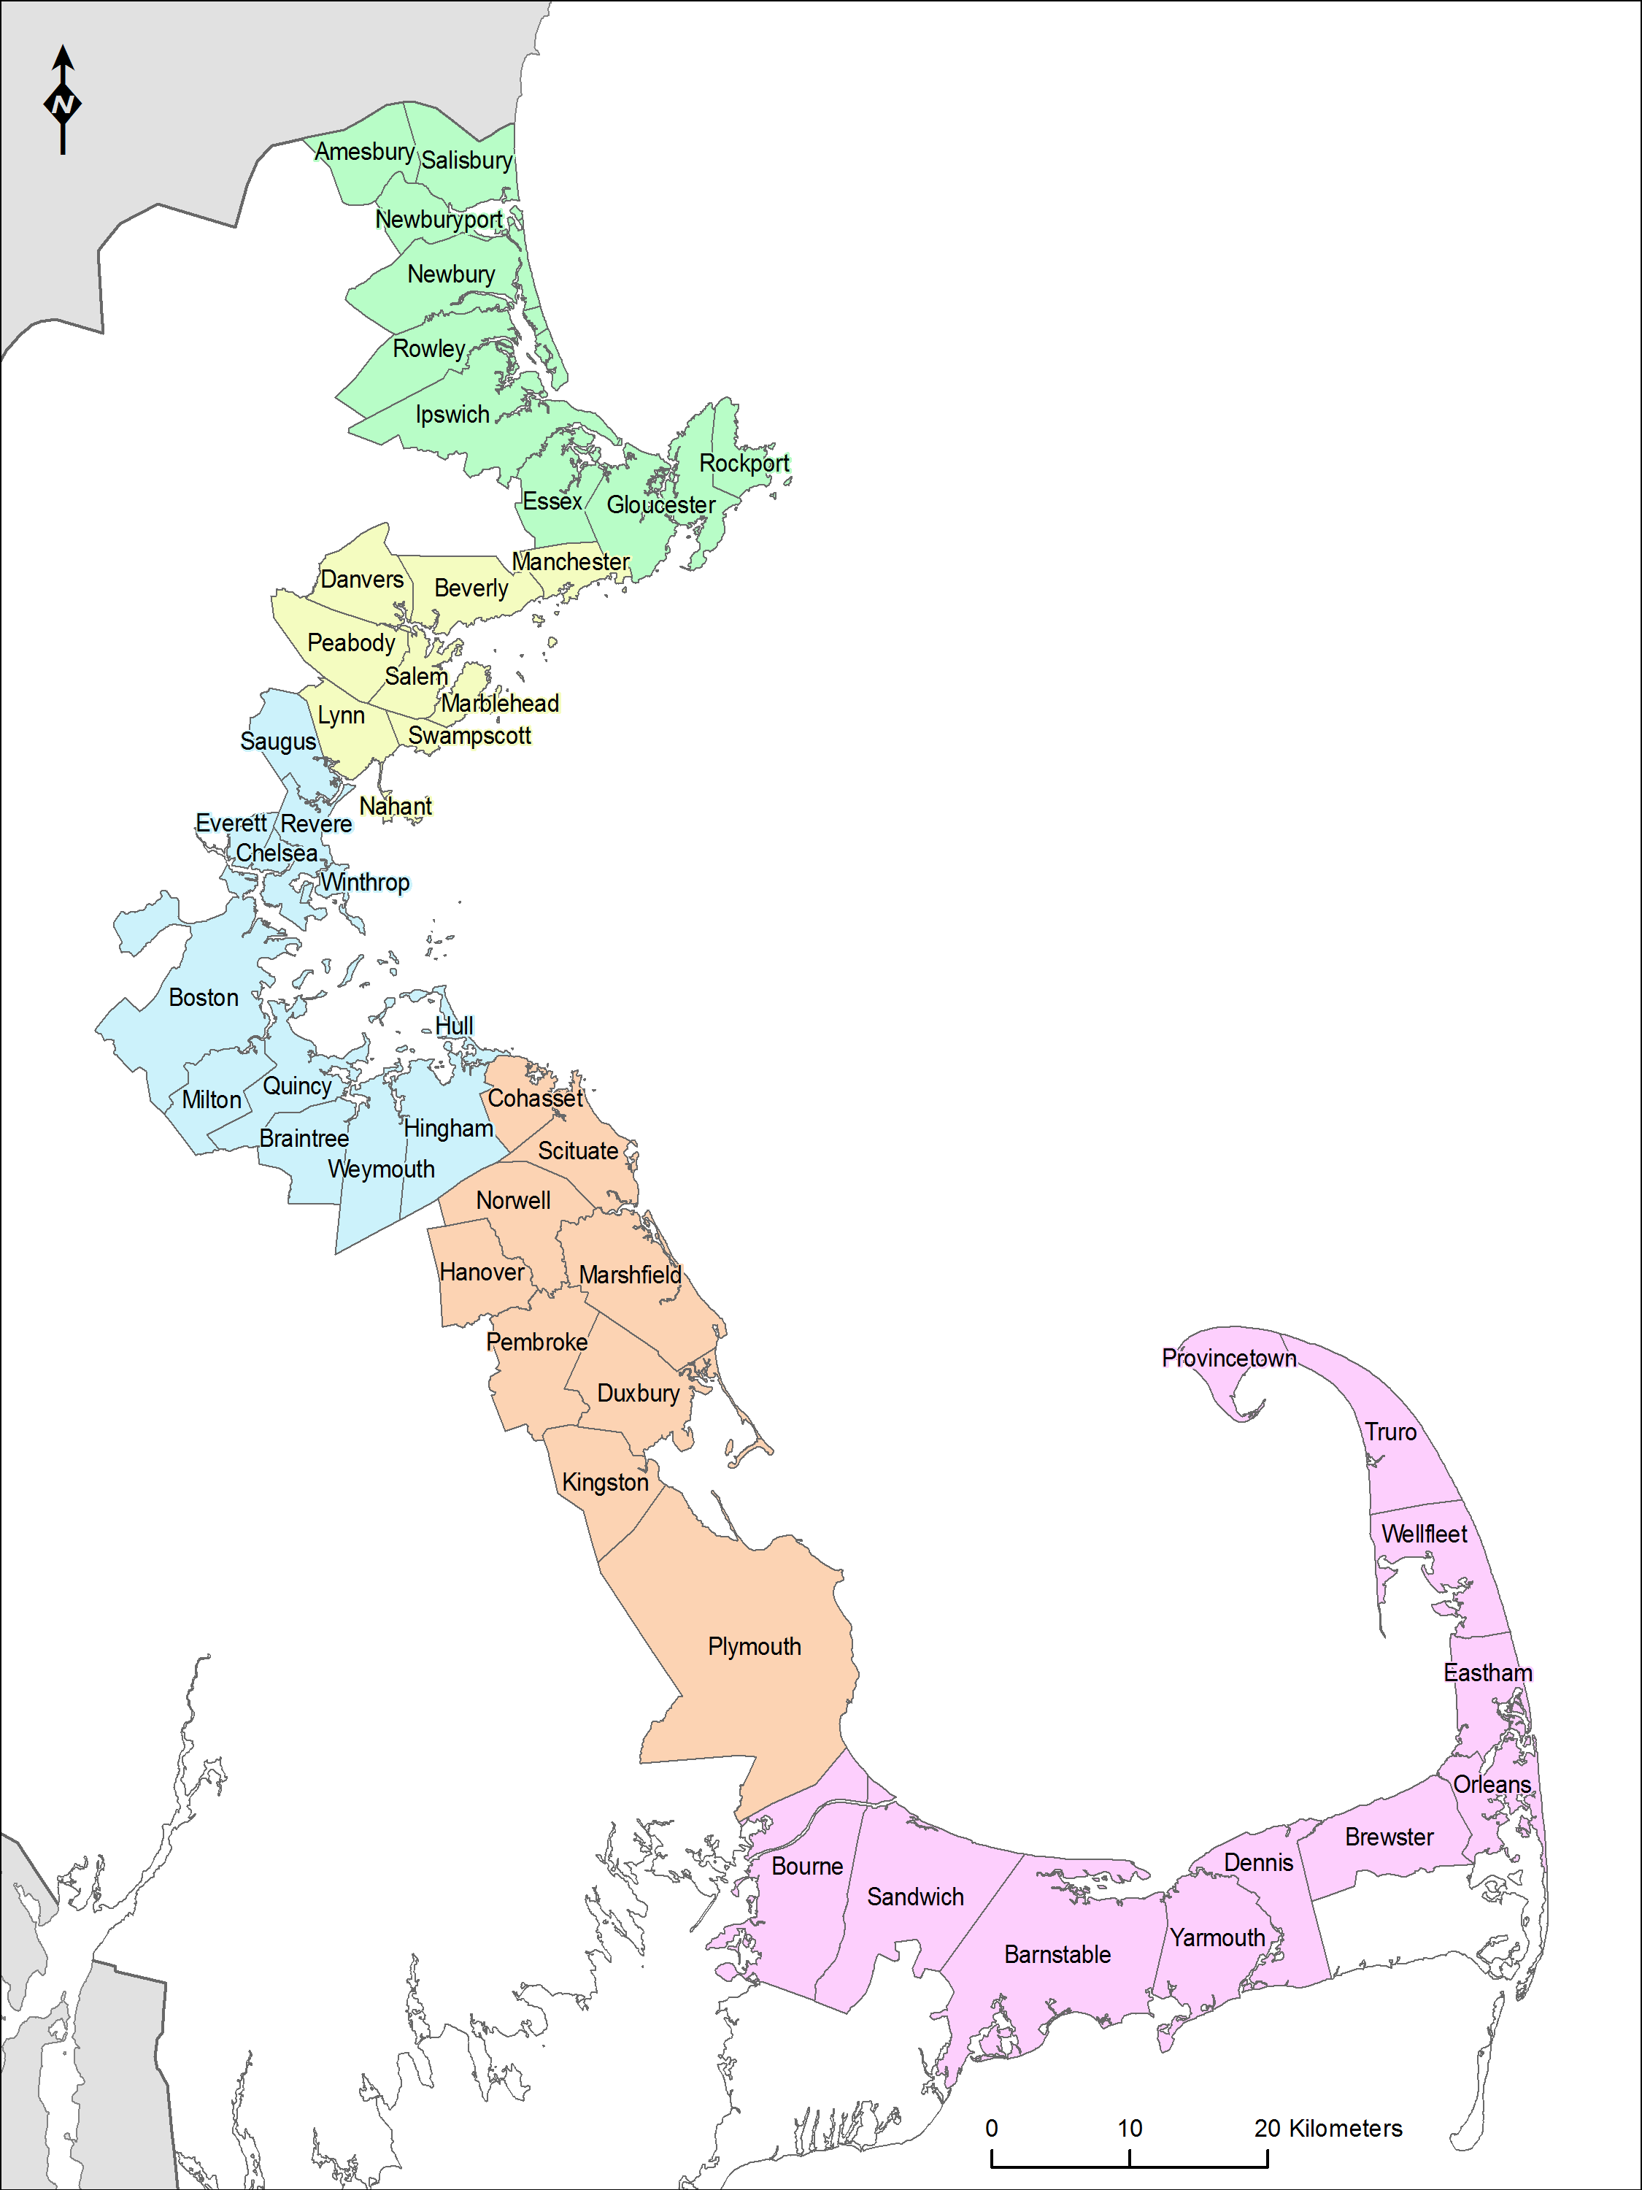

Figure 2
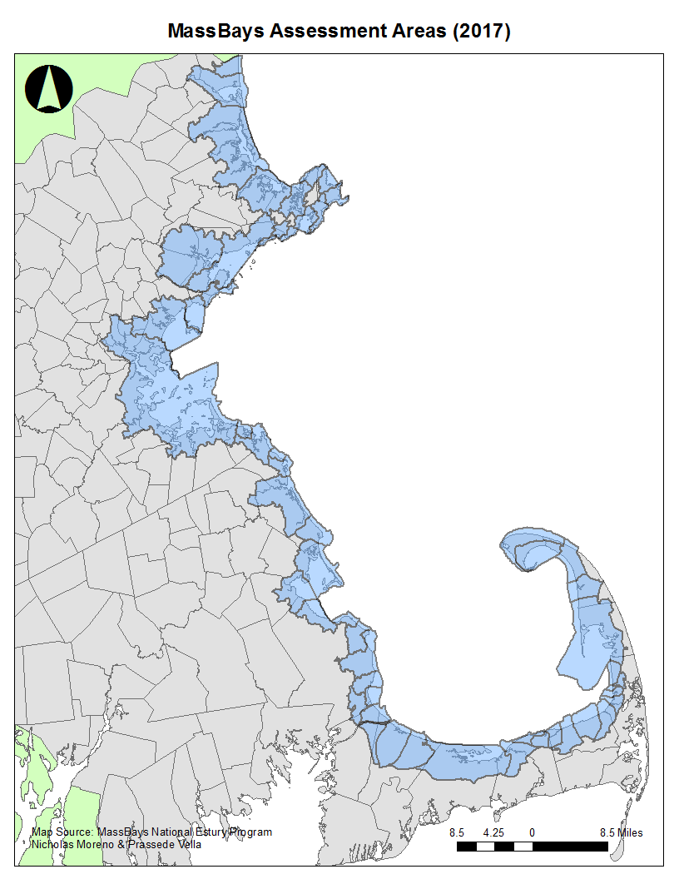

Attachment B
Sample Selection Criteria (Scoring Sheet) for Pre-Proposals

- Project goal and outcomes Score: _______ of 35 points

Assessment maximum possible points
Is there a clearly demonstrated need and justification for the action described in the pre-proposal (e.g., restoration, management efforts, data collection)? | 10
Are the project goal(s) and anticipated outcomes clearly articulated? | 5
Is the project relevant to the MassBays CCMP? | 10
Does the project address a priority action identified by MassBays? | 10

- Anticipated benefits Score: _______ of 30 points

Assessment maximum possible points
Does the project present a clear, logical, and achievable solution to the stated need? | 10
Does the project have a realistic potential of achieving anticipated outcomes? | 10
If a planning effort is proposed, will the project set the groundwork for future implementation funding? | 10
If a research or monitoring effort is proposed, will the project provide a basis for future applied research or management action? | 10

- Qualifications and Budget Score: _______ of 15 points

Assessment maximum possible points
Do the project lead/manager and partners demonstrate capacity to implement the project as described? | 5
Is the budget reasonable for the work proposed? | 5
Does the project provide a match greater than 25% of total project cost? | 5

4) Transferability Score: _______ of 20 points

Assessment maximum possible points
Are anticipated outcomes transferable to other regions? Can the approach be implemented in other assessment areas or regions? | 10
Are plans to share the approach and/or findings with specific target audiences adequate? | 10

Attachment B (Continued)
Sample Selection Criteria (Scoring Sheet) for Full Proposals

- Project need, goals, and outcomes Possible score: 25 points
Request to applicants:
Problem Description
- Describe the assessment area(s) need(s) and/or challenges that this project will address. Cite previous work to document the problem and any management needs.
- Describe the location and assessment area(s) where the work will be focused and the habitats/water bodies of concern. A locus map of the project must be attached.

Project Goals and Anticipated Outcomes
- Describe the goals of the proposed project. Goals should be explicitly connected to desired outcomes of the project and any anticipated management activities. Connect the project to the MassBays CCMP. For example:
  - Document and compare nutrient loads and habitat conditions in areas A and B.
  - Advance activities described in the MassBays CCMP Strategy 3.2.
- Describe the anticipated short-, medium-, and long-term outcomes that will result from the completion of this project. Connect project outcomes to desired CCMP outcome(s). For example:
  - Short-term outcome: Data regarding embayment-specific nutrient loads are available.
  - Medium-term outcome: Connections between nutrient loading and habitat condition inform management decisions.
  - Long-term outcome: Changes in local nutrient loads result in improved habitat conditions.
  - CCMP Environmental Outcome: Restored natural communities.

Evaluate whether the proposed project:
__ is consistent with the strategies and advances the MassBays CCMP goals.
__ focuses on one or more of the 68 assessment areas within the MassBays planning area.
__ presents a clearly defined need for the project in the assessment area of interest, including specific end users.
__ draws from existing knowledge and materials
__ builds on existing work and develops new knowledge that will inform the State of the Bays.
__ clearly articulates the goal(s) of the project.
__ describes outcomes that are clearly connected to desired goal(s).

Reviewer Comments:

Attachment B (Continued)
Sample Selection Criteria (Scoring Sheet) for Full Proposals
- Project approach and evaluation plan Possible score: 30 points
Request to applicants:
- Provide a detailed description of proposed methodology and approach, including the potential for transferability to other assessment areas and ecosystem problems.
- Identify project staff, partners, and subcontractors (if applicable) and describe their roles and responsibilities in the project.
- Provide a Scope of Work/Tasks to be completed under grant request that includes:
- A detailed, step-by-step narrative for each task including supporting reference materials, plans, tables, or graphics, as well as an estimated cost associated with each task.
- If applicable, study design including methods of data collection, analyses, and QA/QC (including QAPP).
- Timeline and anticipated milestones, including written products and other deliverables.
- List interim measures in progress toward anticipated short-term and medium-term outcomes and anticipated project benefits and describe how they will be tracked and documented.

Evaluate whether the proposed project:
__ generates products or services that will result in concrete management activities or on-the-ground projects, e.g., implementation of BMPs or restoration efforts.
__ is focused on addressing ecological functions of ecosystem resources and/or impacts of stressors
__ addresses local priority concerns
__ includes work in underserved communities
__ approach, methodology, and anticipated outcomes are based on sound scientific principles.
__ clearly aligns task-specific budgets within project scope and timeline.
__ identifies outcome and impact measures to assess progress of the project towards anticipated goals.
Reviewer Comments:

- Project benefits and transferability Possible score: 15 points

Request to applicants:
- Articulate the direct benefits of the project to the local ecosystem and resource management.
- Describe how the project results and findings may be applied beyond the target assessment area(s).
- Identify specific target audiences for the project approach and results, and describe plans for sharing methodologies, results, conclusions, and management implications with those audiences. Include the anticipated reach of your dissemination plan (local, regional, national).

Evaluate whether the proposed project:
__ has reasonable potential to benefit the local ecosystem and/or local resource management planning.
__ will develop an approach or pilot a solution that can be applied to other assessment areas.
__ includes a well-thought-out dissemination component that describes target audience(s), communication methods suitable for the audience(s), and anticipated reach.
Reviewer Comments:

Attachment B (Continued)
Selection Criteria (Scoring Sheet) for Full Proposals

- Qualifications and partnerships Possible score: 10 points

Request to applicants:
- Describe the qualifications of the project’s lead applicant and staff.
- Describe the qualifications of partners and/or subcontractors relevant to their roles.

Evaluate whether the applicant:
__ demonstrates sufficient organizational capacity to administer and conduct the proposed scope of work.
__ clearly describes partner and/or subcontractor roles and contributions.
__ includes local stakeholders, e.g., municipal officials and underserved populations.
__ builds on or establishes new partnerships that will improve the likelihood of success of the proposed project and future implementation projects.
__ provided letters of support from collaborating partners.
__ provided thoughtful letters of support from other stakeholder or interest groups.

Reviewer Comments:

- Project budget, match, and administration Possible score: 20 points

Response request:
- Use the template to provide a detailed, itemized budget breakdown for the funds being requested. [salaries, fringe, subcontract, other direct costs, indirect costs]
- Clearly indicate the fringe benefits and indirect/direct overhead rates. Provide justification detail for travel, supplies, etc.
- Describe the source of match, including both cash and in-kind contributions.

Evaluate whether:
__ the proposed scope of work, timeline and budget are detailed, realistic and clear.
__ where applicable, a strategy for acquiring permits is outlined.

Evaluate whether the budget:
__ includes budget breakdown.
__ demonstrates that the project is cost-effective.
__ each partners’ match is confirmed in their letter of support.
__ match amount is equal to or more than 25% of the total project cost.
__ indirect costs, if requested, are reasonable. Note: While submissions will not be disqualified because of high indirect program rates, rates of 25% or lower will be considered evidence of cost-effectiveness.
Reviewer Comments:

Attachment C

Pre-proposal cover sheet and narrative components

Massachusetts Bays national estuary Partnership

FY24 healthy estuaries grants
Request for Response MassBays-24-01

Name of Applicant: ________________________________________________

Contact Information
Name: _________________________________________________________
Title: _________________________________________________________
Organization: _________________________________________________________
Phone: _________________________________________________________
Email: _________________________________________________________

Address: _________________________________________________________

Project Title: _______________________________________________________

Target Assessment Area(s)­: ____________________________________________

Amount Requested: _____________________________________________

Match Amount (at least 25% of TOTAL project cost): ___________________

Total Project Cost: _______________________________________________

Attachment C (Continued)

Pre-proposal cover sheet and narrative components

The pre-proposal provides a summary of the proposed project according to the information requested below. Please limit your response to two (2) pages (single-spaced, 11-point font) including figures, tables etc.

Describe the project need, goal(s), anticipated outcomes, and relevance to MassBays goals and management priorities (see RFR Section 2B).

- Describe the proposed approach, and how and with whom the approach and/or findings will be shared.

- Provide a draft timeline for the project.

- List project partners and their anticipated roles.

Attachment D

Full Proposal cover sheet and narrative components

Massachusetts Bays national estuary Partnership

FY24 healthy estuaries grants
Request for Response MassBays-24-01

Name of Applicant: ________________________________________________

Contact Information
Name: _________________________________________________________
Title: _________________________________________________________
Organization: _________________________________________________________
Phone: _________________________________________________________
Email: _________________________________________________________

Address: _________________________________________________________

Project Title: _______________________________________________________

Project Partners: _____________________________________________________

Target Assessment Area(s): ___________________________________________

Amount Requested: _____________________________________________

Match Amount (at least 25% of TOTAL project cost): __________________

Total Project Cost: _____________________________________________

Attachment d (Continued)

Full Proposal cover sheet and narrative components

Problem Description
- Describe the assessment area(s) need(s) and/or challenges that this project will address. Cite previous work to document the problem and any management needs.
- Describe the location and assessment area(s) where the work will be focused and the habitats/water bodies of concern. A locus map of the project must be attached.

Project Goals and Anticipated Outcomes
- Describe the goals of the proposed project. Goals should be explicitly connected to desired outcomes of the project and any anticipated management activities. Connect the project to the MassBays CCMP. For example:
  - Document and compare nutrient loads and habitat conditions in areas A and B.
  - Advance activities described in the MassBays CCMP.
- Describe the anticipated short-, medium-, and long-term outcomes that will result from the completion of this project. Connect project outcomes to MassBays CCMP outcome(s). For example:
  - Short-term outcome: Data on embayment-specific nutrient loads are available.
  - Medium-term outcome: Connections between nutrient loading and habitat condition inform management decisions.
  - Long-term outcome: Changes in local nutrient loads result in improved habitat conditions.
  - CCMP Environmental Outcome: Restored natural communities.

Project Approach
- Provide a detailed description of the proposed methodology and approach, including the potential for transferability to other embayments and ecosystem problems.
- Identify project staff, partners, and subcontractors (if applicable) and describe their roles and responsibilities in the project.
- Provide a Scope of Work/Tasks to be completed under grant request that includes:
- A detailed, step-by-step narrative for each task including supporting reference materials, plans, tables, or graphics, as well as an estimated cost of each task.
- If applicable, study design including methods of data collection, analyses, and QA/QC (including QAPP).
- Timeline and anticipated milestones, including written products and other deliverables.

Project Measures/Outputs
- List interim measures in progress toward anticipated short-term and medium-term outcomes and anticipated project benefits and describe how they will be tracked and documented.

Project Benefits
- Articulate the direct benefits of the project to the local ecosystem and resource management scheme.
- Describe how the project results may be applied beyond the target assessment area.

Attachment d (Continued)

Full Proposal cover sheet and narrative components

Outreach/Dissemination
- Identify specific target audiences for the project approach and results, and describe plans for sharing methodologies, results, conclusions, and management implications with those audiences. Include the anticipated reach of your dissemination plan (local, regional, national).

Qualifications
- Describe the qualifications of the project’s lead applicant and staff.
- Describe the qualifications of partners and/or subcontractors relevant to their roles.
- Resumes may be included as part of the application packet but are not required.

Project Budget
- Use the template below to provide a detailed, itemized budget breakdown for the funds being requested.
- Clearly indicate the fringe benefits and indirect/direct overhead rates. Provide justification detail for travel, supplies, etc.
- Describe the source of match, including both cash and in-kind contributions.

MassBays Healthy Estuaries Grants Budget Format
BUDGET ITEM |  |  | GRANT $ | MATCH $ | TOTAL $
Salaries | Hours (#) | Hourly Rate ($)
[Staff name & role]
[Staff name & role]
Fringe | Rate (%) | Assessed against ($)
Contractual
[Contractor name and role]
Other Direct Costs
Travel (miles at $0.45/mile)
Supplies (consumables)
Indirect charges | Rate (%) | Assessed against ($)
TOTALS

Attachment d (Continued)

Full Proposal cover sheet and narrative components

Required Supporting Materials:
Project proposals must include the following supporting materials with the response. The following documents must be attached with the full proposal:
- Proof of support of the organization, such as an IRS letter of non-profit status or, in the case of municipally sponsored groups, a letter of support on letterhead by its overseeing municipal board, town manager, or mayor’s office.
- Disclosure of any concurrent funding requests in support of the proposed project.
- A statement from an authorized signatory acknowledging and accepting the following:
  - The organization commits to match at least 25% of total project cost and acknowledges that funding is provided on a reimbursement basis.
  - Matching funds have been approved and/or appropriated (or are in the process of being approved) by the organization’s authorized body.
- Partner letters: Statement of commitment on letterhead from each partner detailing the partner’s intention to contribute to the project as described in the proposal narrative.
- Letters of support: Include up to three statements of support on letterhead and must be relevant to the proposed project. Generic letters of support will not be reviewed. Statements of support must be submitted with the response and not separately.

Suggested Supporting Materials:
Project Goals, Activities, and Outcomes may be presented in a logic model, demonstrating connections between proposed approach and anticipated impacts. Refer to the University of Wisconsin’s Program Development and Evaluation website for guidance and samples: http://www.uwex.edu/ces/pdande/evaluation/evallogicmodel.html.

Cash contributions are those funds that will be used to purchase goods or services associated with the project. In-kind contributions represent the value of non-cash contributions provided by the applicant, e.g., in the form of charges for real property and non-expendable personal property and the value of goods and services directly benefiting and specifically identifiable to the project.
Refer to MassBays’ 2017 Ecosystem Delineation and Assessment available at MassBays Assessment Areas (arcgis.com)
Refer to MassBays’ 2017 Ecosystem Delineation and Assessment available at MassBays Assessment Areas (arcgis.com)

